# Trainer Guide *Admin in a day*

Content can be found at the following Git link:

<https://github.com/microsoft/powerapps-tools/tree/master/Administration/AdminInADay>

Table of Contents

Trainer Guide *Admin in a day* 1

Environments 1

Agenda 2

Overview 3

Module 01 Secure 4

Possible demos 4

Hands on 4

Module 02 Monitor 6

Possible demos 6

Hands on 6

Module 03 Alert & Action 8

Possible demos 8

Hands on 8

Module 04 Deploy 10

Possible demos 10

Hands on 10

## Environments

Need details for student and instructor setup

## Agenda

The agenda is full! The day is broken into four main areas: **Secure, Monitor, Alert & Action**; and **Deploy**. Times below are suggestions. As the day progresses you might find yourself breezing through one topic quickly and on another you might need a few extra minutes to secure the understanding of all the students. The time for lunch is planned as a working lunch, with active Q&A.

For each hands-on activity, you will see a couple of common themes; always start with a private/incognito browser session and make sure you are in the desired environment. This is helpful in training, so students don’t accidentally work in their company’s tenant. This is also reinforcing good practices for when they are in their job doing this work in the future.

|  |  |
| --- | --- |
| 9:00-11:40  **Secure** | Welcome & Logistics  Presentation  Questions  Hands on Lab  Questions + Break |
| 11:40-2:00  **Monitor** | Presentation  Questions + Lunch  Hands on Lab  CoE Starter Kit Demo  Questions + Break |
| 2:00-4:00  **Alert & Action** | Presentation  Questions  Hands on Lab  CoE Starter Kit Demo  Questions + Break |
| 4:00-5:30  **Deploy** | Presentation  Questions  Hands on Lab  Wrap-up |

## Overview

The purpose of these slides is to set the tone and expectations for the day. You have some probing questions here, but feel free to add your own. This is where you get to know a little more about your audience. Particularly with administrators, they all come from varying degrees of expertise. These questions will better allow you to recognize students that might need more help, or students that might well be experts on some topics and add to the conversations.

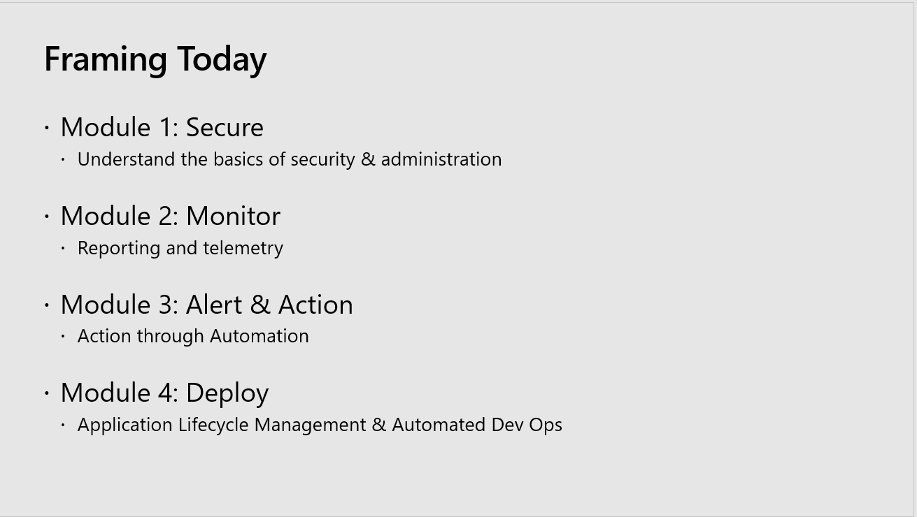

## Module 01 Secure

Understand the basics of security & administration. The key takeaways here:

* Know your audience, who is contributing to your environments, how you can securely enable them.
* The types of environments you will encounter, how to manage them and get the most out of them.
* Security, security roles and data loss prevention policies.

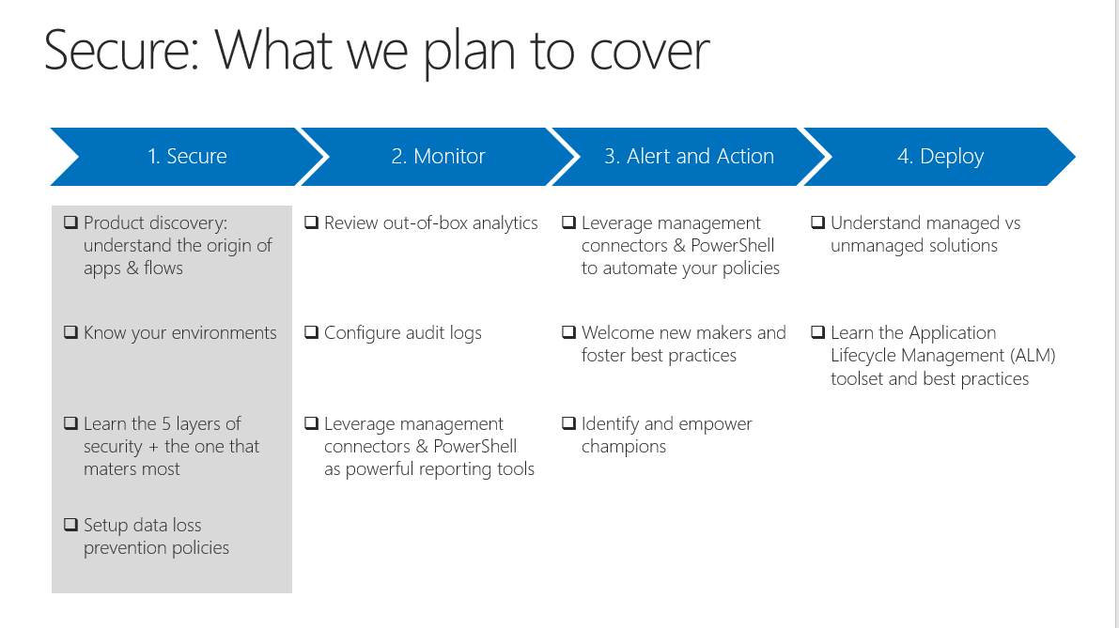

### Possible demos

* Depending on the background of your audience, a simple lesson in CDS security roles could be valuable.
* Show any of the ingredients from this module’s lab.

Hands on

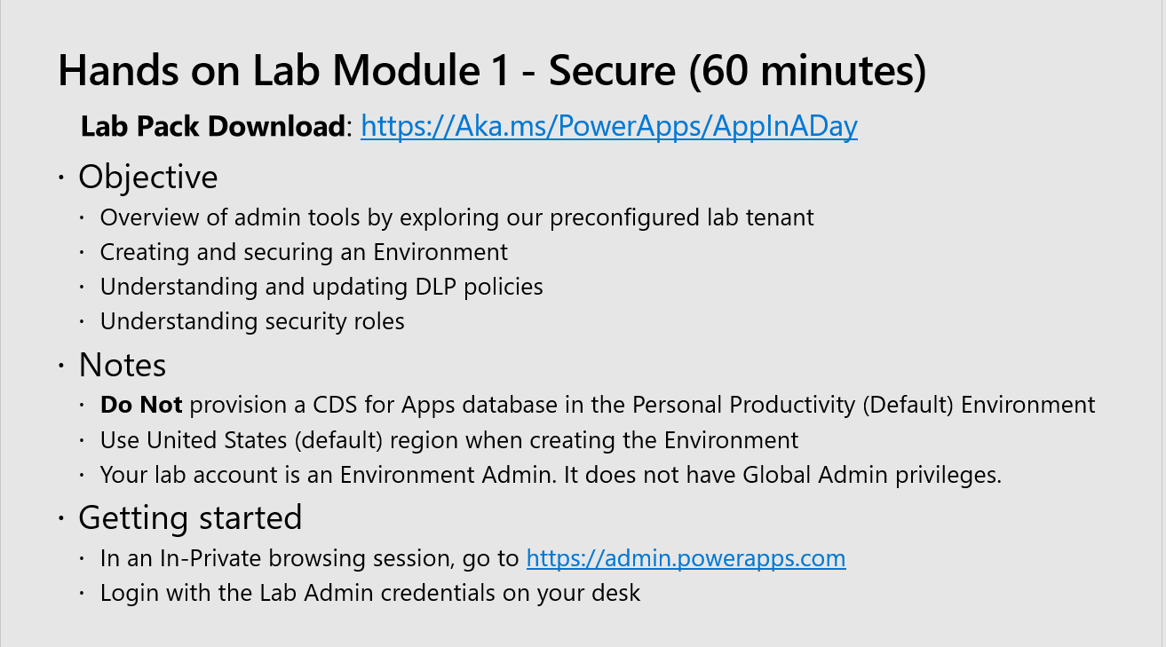

## Module 02 Monitor

Reporting and telemetry. The key takeaways here:

* Available data analytics for admins and makers
* Canvas apps, Microsoft Flow and CDS analytics
* Activity logging for Office 365 and CDS and using these as triggers for automation
* Leverage PowerShell Cmdlets for management reporting on activities
* Service Health Dashboard & Message Center

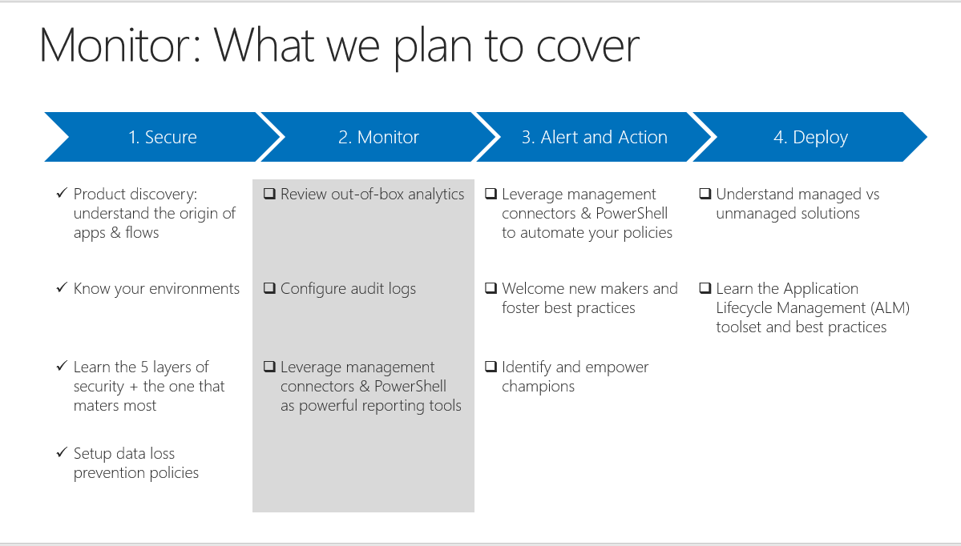

### Possible demos

* CoE Starter Kit Demo
* Tour of analytics available
* The anatomy of a Flow triggered by activity

Hands on

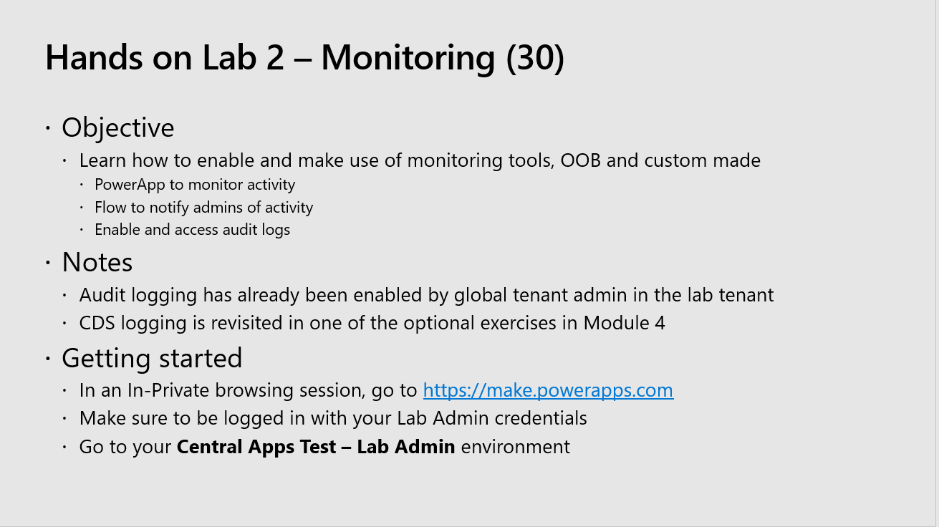

## Module 03 Alert & Action

Action through Automation. The key takeaways here:

* Automate with PowerShell cmdlets, separate cmdlets for app creators and administrators
* Build the policies you need, when to use what options
* Engage with makers early, create champions

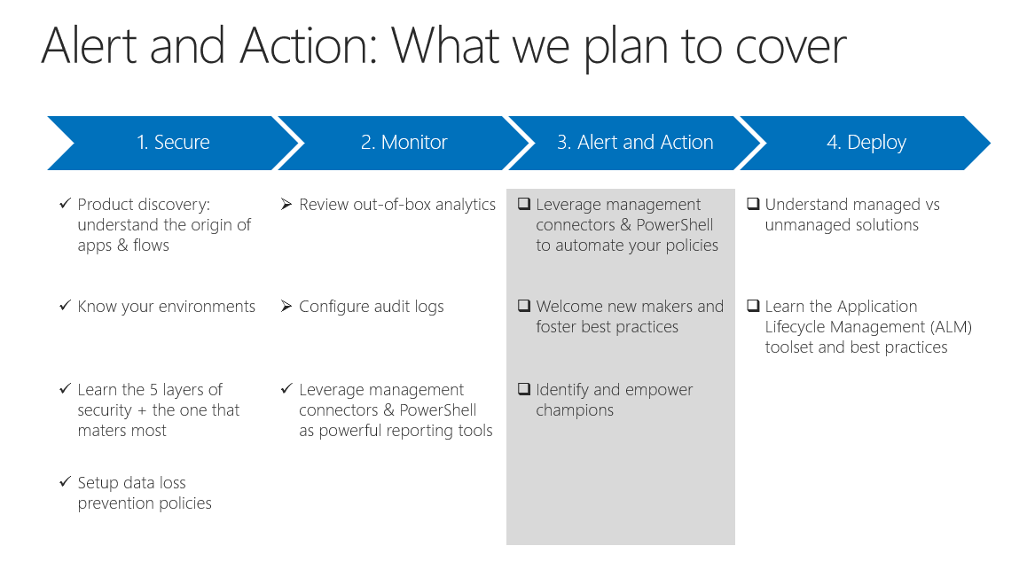

### Possible demos

* CoE Starter Kit Demo
* Build a simple policy
* Build a flow to send an email to new makers

Hands on

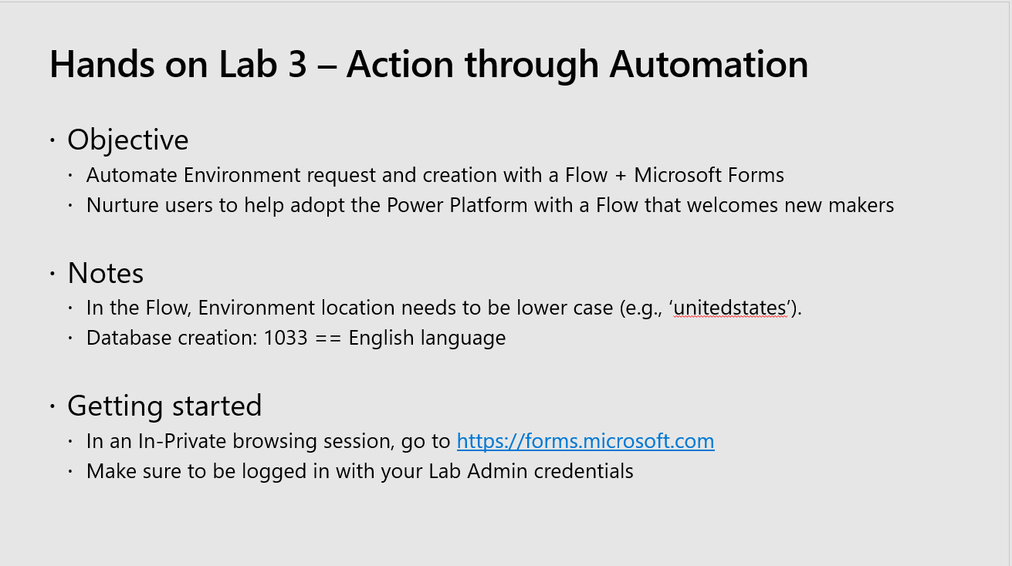

## Module 04 Deploy

Application Lifecycle Management & Automated Dev Ops. The key takeaways here:

* When to use managed solutions, when to use unmanaged
* Deployment scenarios
* Available tools
* Unlearning bad habits

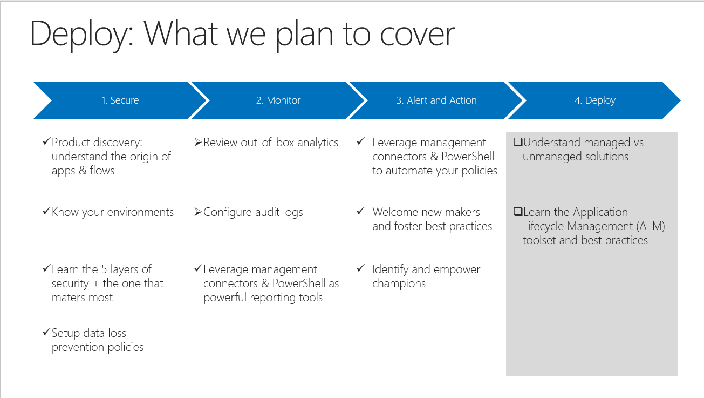

### Possible demos

* Simple solution movement from dev to prod
* Patch solution from dev to prod

Hands on

